Report
Of
SUMMER INTERNSHIP

Submitted
To
School of Computer Science and Engineering
IILM University, Greater Noida, U.P.

In partial fulfilment of the requirement of degree of
B.Tech CSE



By
Roll Number of: 2410030535
Name of Student: JANVI JAISWAL
Batch: 2024-2028

2026-27

CANDIDATE’S DECLARATION

I, Janvi Jaiswal do hereby declare that the internship report titled “frontend developer at satvify” has been completed by me to fulfil the requirement for the award of the degree of Bachelor of Technology in CSE. All the references have been quoted and I have not taken as such any material from any other source. I affirm to you that this report is my own and has not been submitted to any other institute for any degree/diploma requirement and further I shall be solely responsible for any kind of copyright violation in this regard.

Signature janvi
Student Name:- Janvi Jaiswal
Roll No:- 2410030535

ACKNOWLEDGEMENT

I am using this opportunity to express my gratitude to everyone who supported me throughout the Internship Program. I am thankful for their aspiring guidance, invaluably constructive criticism and friendly advice during this work. I am sincerely grateful to them for sharing their truthful and illuminating views on a number of issues related to this work.
I express my gratitude to my parents for their blessings.

Signature janvi
Student Name:- Janvi Jaiswal
Roll No:- 2410030535

INTERNSHIP OFFER / JOINING CONFIRMATION LETTER

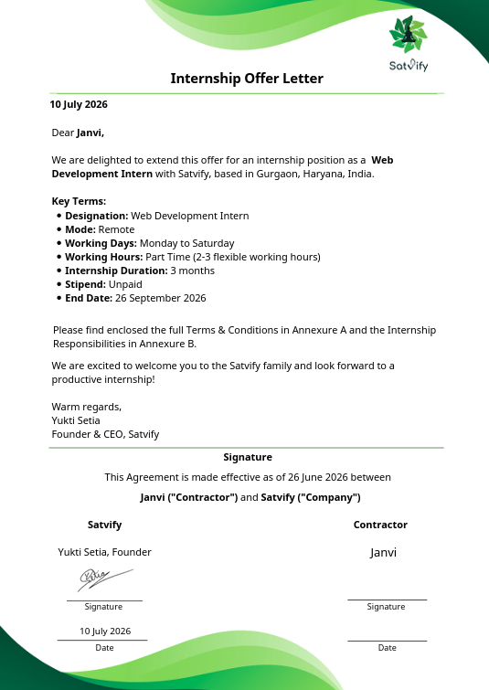

NOTE:- As the summer internship is currently ongoing, the official Internship Completion Certificate will be issued by Satvify upon conclusion of the full internship tenure. Attached above is the official Offer Letter / Joining Confirmation provided by the organization.

TABLE OF CONTENTS

Chapter No. | Chapter Name | Page Nos.
 | Cover Page | ----
1. | Candidate’s Declaration
2. | Acknowledgment
3. | Internship Completion Certificate
4. | Project Description  4 .1 Introduction  4.2 Organization Profile  4.3 Problem Statement  4.4 Project Objectives  4.5 Scope of the Project  4.6 Technologies and Tools Used  4.7 System Architecture  4.8 Methodology  4.9 Expected Outcomes  4.10 Certificates of completion and other communication mail proof must be attached
5. | Bibliography/References

PROJECT DESCRIPTION

4.1 Introduction
During my ongoing summer internship at Satvify, I am serving as a Frontend Developer contributing to the core user interface of the organization's digital platforms. My primary project responsibility involves designing, building, and optimizing an engaging, responsive, and user-friendly Subscription Page.
Subscription pricing interfaces serve as a critical component for digital service platforms, acting as the primary conversion touchpoint for upgrading casual visitors into active subscribers. Creating an intuitive UI that clearly presents membership tiers, features, and pricing structures—while ensuring fluid cross-device responsiveness—is the primary focus of this frontend development project.

4.2 Organization Profile
Satvify is an innovative health-tech and lifestyle startup dedicated to encouraging conscious living through pure vegan and satvic dietary practices. Originating through institutional incubation opportunities, Satvify bridges traditional wellness principles with modern digital access, offering users curated products, meal plans, and holistic community support.
- Industry: Health, Wellness & Digital E-Commerce
- Core Philosophy: Pure Vegan and Satvic Lifestyle Solutions
- Domain: Web Application & UI/UX Development
- Role Assigned: Frontend Developer Intern

4.3 Problem Statement
Prior to this project, Satvify required a dedicated, modern, and high-converting frontend subscription page to allow users to subscribe seamlessly to their recurring satvic wellness plans. The specific challenges being addressed were:
- Lack of Visual Hierarchy: Communicating multi-tiered pricing plans (e.g., basic vegan meal guidance vs. premium satvic product boxes) without cluttering the screen or confusing users.
- Device Inconsistency: Ensuring uniform layout behavior, alignment, and responsiveness across desktops, tablets, and smartphones.
- Static & Rigid UI: Delivering dynamic frontend features (such as monthly vs. annual pricing toggles with discount indicators) without requiring disruptive full-page reloads.
4.4 Project Objectives
- To design and develop a production-ready, dynamic Subscription Page using core frontend web technologies: HTML5, CSS3, and Vanilla JavaScript (ES6+).
- To implement modern CSS layout techniques (Flexbox & CSS Grid) and Media Queries to achieve full responsiveness across all viewports.
- To construct client-side dynamic DOM interactions, including billing cycle toggles (Monthly vs. Annual discounts) and active state plan highlights.
- To adhere to clean code principles, ensuring modularity, easy maintenance, and fast client-side rendering speed.
4.5 Scope of the Project
The project scope centers strictly on client-side (frontend) engineering:
- Semantic HTML5 structuring of pricing cards, feature lists, and Call-to-Action (CTA) buttons.
- Custom CSS styling matching Satvify's brand aesthetics, dynamic hover states, transitions, and responsive breakpoints.
- JavaScript DOM manipulation for interactive elements (pricing toggles, active plan highlights).
- Cross-browser testing and responsive UI debugging.
4.6 Technologies and Tools Used

Category | Tool / Technology | Purpose
Core frontend | HTML5  CSS  JavaScript | Building structured, accessible, and semantic web elements.  Layout design, styling, Flexbox/Grid, transitions, and media queries.  Client-side logic, dynamic pricing toggles, and DOM event handling.
Development Suite | VS Code  Github  Chrome DevTools | Primary Integrated Development Environment (IDE).  Version control, branch management, and code collaboration.  Real-time DOM inspection, CSS debugging, and responsive viewport testing.

4.7 System Architecture
The system follows a lightweight client-side web architecture where user interactions immediately trigger JavaScript events to update the Document Object Model (DOM) dynamically without requiring full page reloads.

4.8 Methodology
- Requirements & UI/UX Breakdown: Reviewed design specifications and converted visual wireframes into structured HTML components reflecting Satvify's branding.
- Semantic Layout Construction (HTML5): Formatted pricing headers, feature lists, badge highlights, and action buttons using proper semantic elements.
- Styling & Responsiveness (CSS3): Applied custom styling using CSS Flexbox and CSS Grid. Media queries were configured for dynamic adjustments on devices ranging from mobile screens ($<768\text{px}$) to large desktop displays ($>1024\text{px}$).
- Interactive Logic (JavaScript): Implemented JavaScript event listeners to:
- Dynamically calculate and update plan prices when switching between Monthly and Annual billing modes.
- Add active state CSS classes to highlighted/selected subscription cards.
- Testing & Code Review: Conducted cross-browser compatibility testing across Chrome, Firefox, and Safari, resolving layout issues prior to code delivery.

4.9 Expected Outcomes
- Fully Functional Subscription Page: Delivered a completed, polished frontend subscription component tailored for Satvify's vegan/satvic offerings.
- Enhanced User Experience: Provided a clean visual hierarchy that allows users to evaluate subscription plans effortlessly.
- 100% Mobile Responsiveness: Ensured seamless layout scaling across all modern mobile, tablet, and desktop viewports.
- Maintainable Codebase: Produced modular HTML, CSS, and JS code adhering to company frontend standards.

4.10 Communication Proof and Project Deliverables

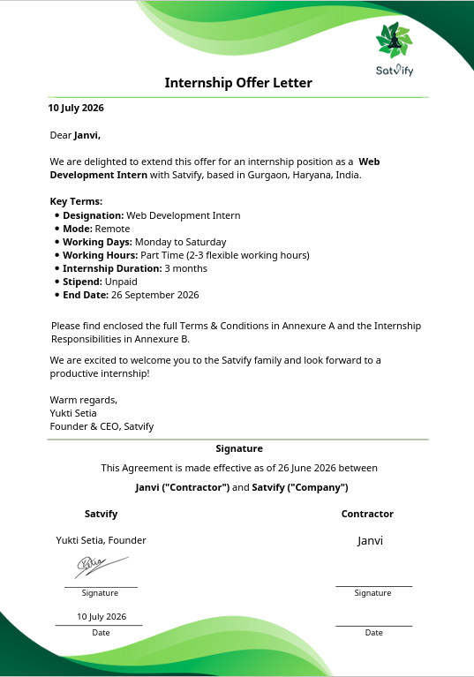

BIBLIOGRAPHY / REFERENCES

- MDN Web Docs. (2024). HTML: HyperText Markup Language. Mozilla Developer Network. Available at: https://developer.mozilla.org/en-US/docs/Web/HTML
- MDN Web Docs. (2024). CSS: Cascading Style Sheets. Mozilla Developer Network. Available at: https://developer.mozilla.org/en-US/docs/Web/CSS
- MDN Web Docs. (2024). JavaScript - Dynamic client-side scripting. Mozilla Developer Network. Available at: https://developer.mozilla.org/en-US/docs/Web/JavaScript
- Duckett, J. (2014). HTML and CSS: Design and Build Websites. John Wiley & Sons.
- Freeman, E., & Robson, E. (2014). Head First JavaScript Programming. O'Reilly Media.

.

